7.53: The net work done during the trip down the barrel is the sum of the energy stored in the spring, the (negative) work done by friction and the (negative) work done by gravity. Using 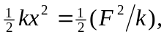 the performer’s kinetic energy at the top of the barrel is

and his speed is 